Vendor Registration
September 24th, 5 pm – 9 pm & 25th, 5 am – 9:30 pm

Basic rules:

- Vendors will be responsible for set up their space, including tents, tables, chairs, table cloths, decorations, or any other promotional materials. (There will be a section for people to sit while eating)

- There will not be electric available. If you need electric, please plan accordingly.

- The event will be located on the north side of Clarksville Airport beginning at 5:00 p.m. on Friday, September 23rd. You may begin setting up as early as you need to. The event will wrap up around 9 – 9:30 pm, depending on the audience. Saturday will kick off at 5 pm and wrap up around 9 – 9:30, again depending on audience. Saturday will be in conjunction with the 100th Annual Chamber Awards. The awards will be over around 8 pm so there may be an influx of the audience briefly after.
- The Vender Registration is $100 for both nights of the event.
- State law requires that all vendors pay sales tax on their revenue from events. It is each individual’s responsibility to make sure they claim their income and collect sales tax. Clarksville – Johnson County Chamber of Commerce does not require any permits, licenses, or ID numbers nor do we provide any forms or assistance in this matter. You should have a tax ID number and submit the appropriate forms to the revenue department.
Application on back

Release of Photos**Once your application is accepted, you grant Clarksville – Johnson County Chamber of Commerce permission to use images of your items for promotional purposes, including but not limited to online and print media. During participation in our event you grant permission to have photographs taken of your likeness, booth and items for the purpose of advertising and promotion online, in print and otherwise.
By submitting application and payment, you agree to the following:
You release Clarksville – Johnson County Chamber of Commerce, its staff, board members, chamber members, Clarksville City, Johnson County, and the Reaching New Heights 2021 event and all of its affiliates from any damage to your person or property that may occur as a result of participation in Reaching New Heights 2021. This includes set up, break down, and the official hours of the event. We make every effort to provide a secure environment. You are solely responsible for all of your belongings, including inventory, tents, decorations and your vehicle. Please do not leave valuables unattended. Reaching New Heights 2021 nor its affiliates are liable for any injuries sustained during participation in this event.

Company Name: ___________________________________________________________________________
Contact Name: ____________________________________________________________________________
Phone Number: _____________________________ Set Up Time Required: ___________________________

Email: ___________________________________________________________________________________
Types of products being sold? Please List ALL: __________________________________________________
__________________________________________________________________________________________
__________________________________________________________________________________________
__________________________________________________________________________________________

__________________________________________________________________________________________

We will send out more information via email closer to the event date regarding your location in
Reaching New Heights 2021.

Interested in being a sponsor for the event??
Contact the Clarksville – Johnson County Chamber of Commerce
to see how you can become more involved!
Jessica, Matt or Holly
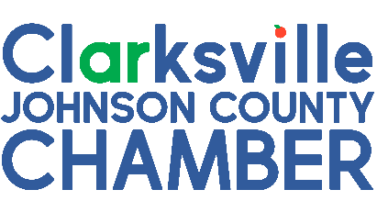
479-754-2340

