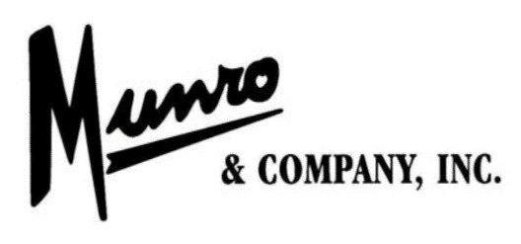
JOB TITLE: Production Worker- Clarksville Footwear
DEPARTMENT(S): Fitting, Lasting and Packing
LOCATION: Clarksville Footwear, 401 S. Cline Road, Clarksville, AR 72830
SCHEDULE: Monday through Friday, 7:00 A.M. – 3:30 P.M.
(Overtime and some Saturdays as needed)
CLASSIFICATION: Non-Exempt
JOB DESCRIPTION
Production Worker performs all tasks involved in the production of Munro & Company Inc.’s products. This includes setting up production materials, cutting, sorting and matching up parts, stitching and sole assembly, lasting and packing. Follow standard work methods and practice safe work habits to ensure production is as efficient and safe as possible.

Job Requirements

  - Pass basic physical examination, hearing test, vision test (corrected minimum 20/40) and be in good physical health (blood pressure, post offer urine drug test).
- Capability to handle materials and equipment to complete assigned job tasks.
  - Possess basic computer and/or machine operator skills may be required.
  - Ability to work successfully with co-workers in a team effort and individually is required.
All production workers will be cross-trained and expected to perform in various areas of production.

Primary Duties and Responsibilities

  - Reads master ticket and performs work as assigned by department supervisor.
  - Sews, cuts, clips or otherwise assembles the materials to produce sub-assemblies or finished product from raw materials.
  - Attach appropriate labels and tags to products and packages.
  - Pack finished goods into correct packages and boxes.
  - Track production on schedule boards.
  - Notify supervisor of mechanical or material issues.
  - Place finished goods on the designated pallet.
  - Maintain a clean and safe work area.
Education, prior work experience and specialized skills and knowledge:
High School Diploma or GED equivalent preferred.
Less than high school education or up to one month of related experience or training or equivalent combination of education and experience.
The position will be required to perform basic math.
Physical DeMANDS AND WORK ENVIRONMENT
The physical demands and work environment characteristics described here are representative of those that must be met by and employee to successfully perform the essential functions of this job. Reasonable accommodations may be made to enable individuals with disabilities to perform the essential functions.
While performing the duties of this job, the employee is regularly required to:
- Have full range of mobility in upper and lower body
- Be able to reach over head
- Be able to work in various positions, including, but not limited to, stooping, standing, bending over, sitting, kneeling, squatting, walking and lifting for extended periods of time.
- Be able to lift, pull and push materials and equipment to complete assigned job tasks.
- Be able to lift 50 lbs. frequently throughout assigned workday.
- Work in environmental heated and/or cooler temperatures (controlled air conditioning and heating required in certain areas for production).
Other Duties
Please note this job description is not designed to cover or contain a comprehensive listing of all activities, duties or responsibilities that are required of the employee for this job. Duties, responsibilities and activities may change at any time with or without notice.

APPLICATION FOR EMPLOYMENT MUST BE MADE IN PERSON AT
MUNRO & COMPANY, INC.
401 S. CLINE ROAD, CLARKSVILLE, AR 72830
BETWEEN: 8:00 A.M. and 2:00 P.M.

AN EQUAL OPPORTUNITY EMPLOYER

